**Azure Coding Challenge – 2**

**Name:** V Venkata Sri Prasad

**Batch:** Data Engineering

**Date:** 21/02/2024

Email : venkatvanniya2002@gmail.com

Question:

Explain Overview of 3 level namespace and creating Unity Catalog objects.

In Unity Catalog, the hierarchy of primary data objects flows from metastore to table or volume:

**Metastores**

* Think of metastores like big containers for organizing information about your data and who can access it.
* They keep track of metadata (like data descriptions) and permissions (like who's allowed to see or change the data).
* Admins create metastores for different regions and attach them to workspaces.

**Catalogs:**

* Catalogs are like folders in a filing cabinet, helping you organize your data assets.
* Each catalog is a collection of related data assets, making it easier to manage and access them.
* Users can see all the catalogs they have permission to use.

**Schemas:**

* Schemas act like sub-folders within catalogs, further organizing your data into groups.
* They contain tables and views, providing a structured way to organize data assets.
* Users with permission can see and use schemas along with their parent catalogs.

**Tables, Views, and Volumes:**

* These are the actual data assets stored within schemas.
* Tables store structured data in rows and columns.
* Views provide different perspectives on the data.
* Volumes govern non-tabular data types, ensuring proper management.

**Models:**

Models are special resources containing advanced information, like machine learning models or data transformation pipelines.They reside at the lowest level in the object hierarchy, alongside tables and views.

Creating Catalog object (overview):

Open the databricks and create a cluster

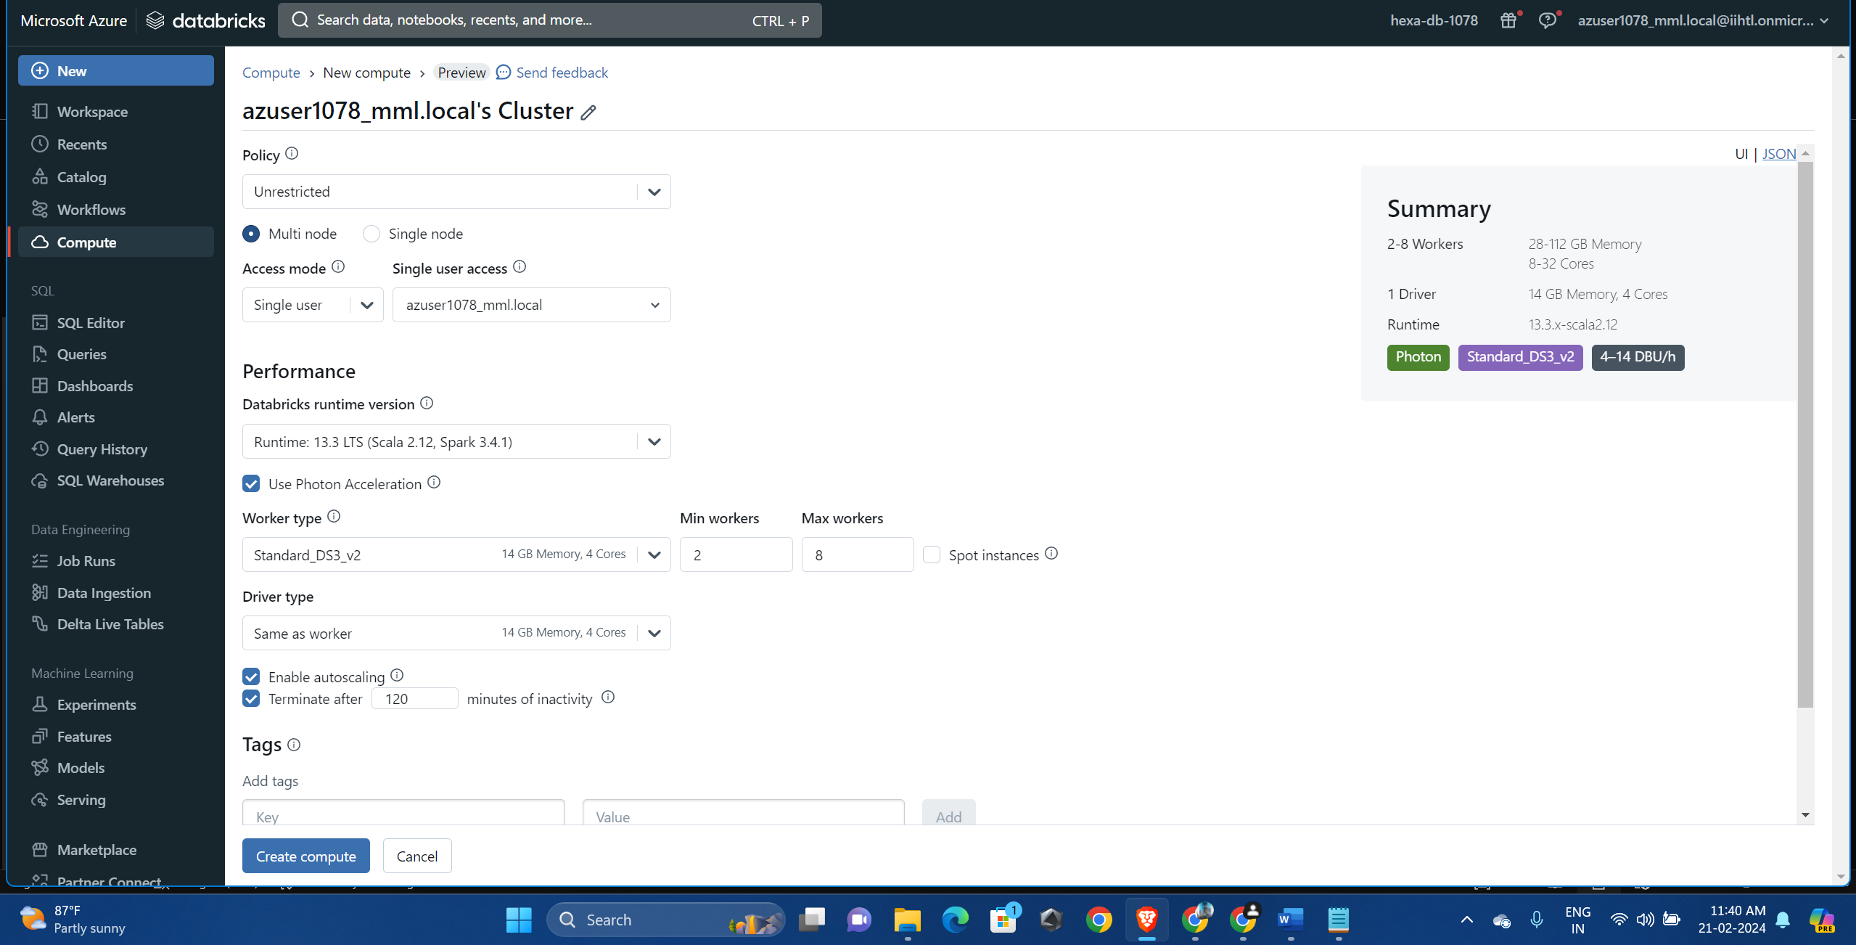

Go to sql warehouses and the start the warehouse (if you have) or Create one.

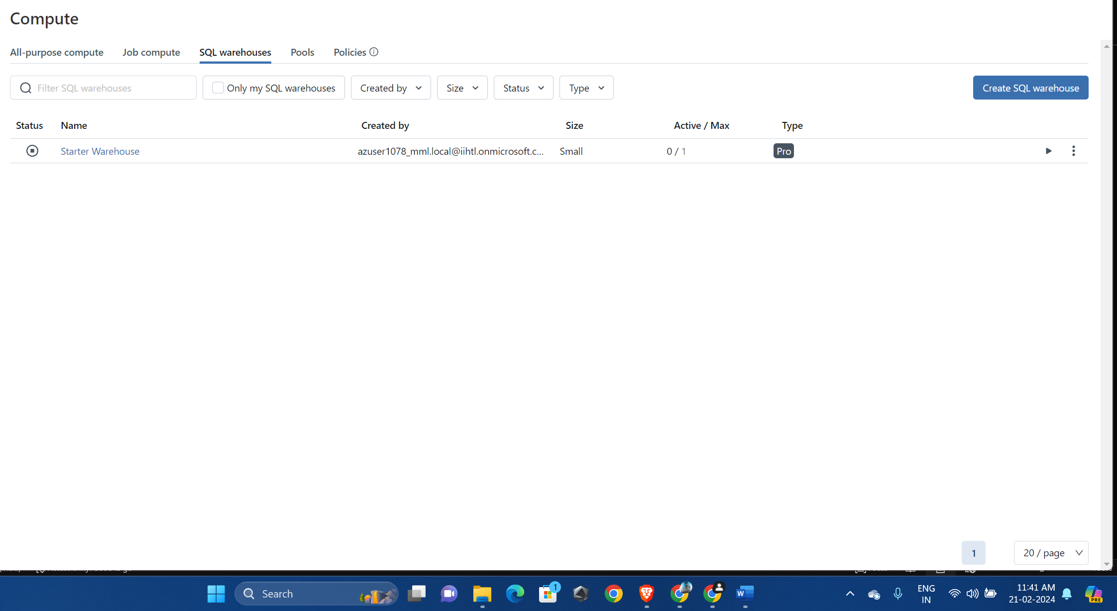

Go to data ingestion and select on azure blob storage

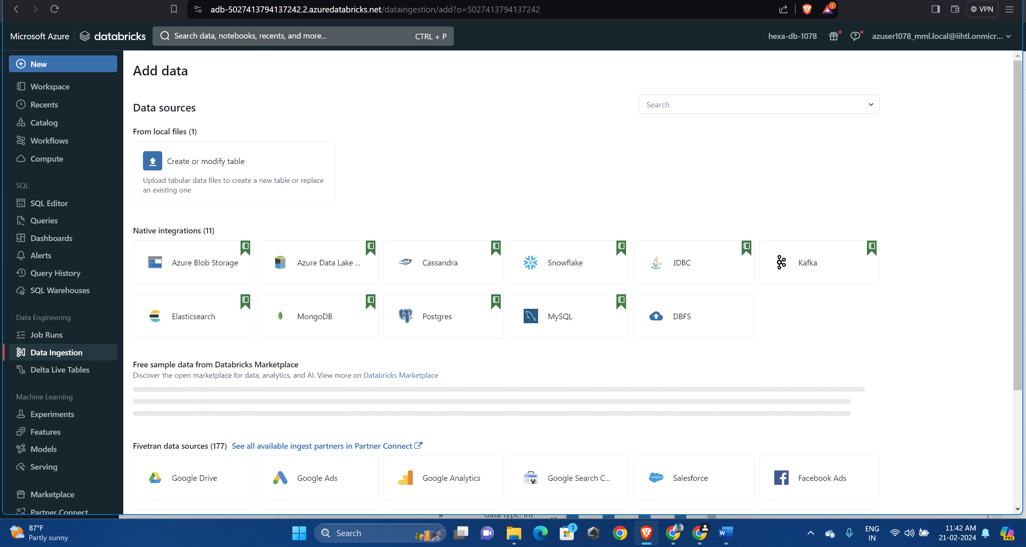

In the notebook , specify the storage account name and access key. Provide file location

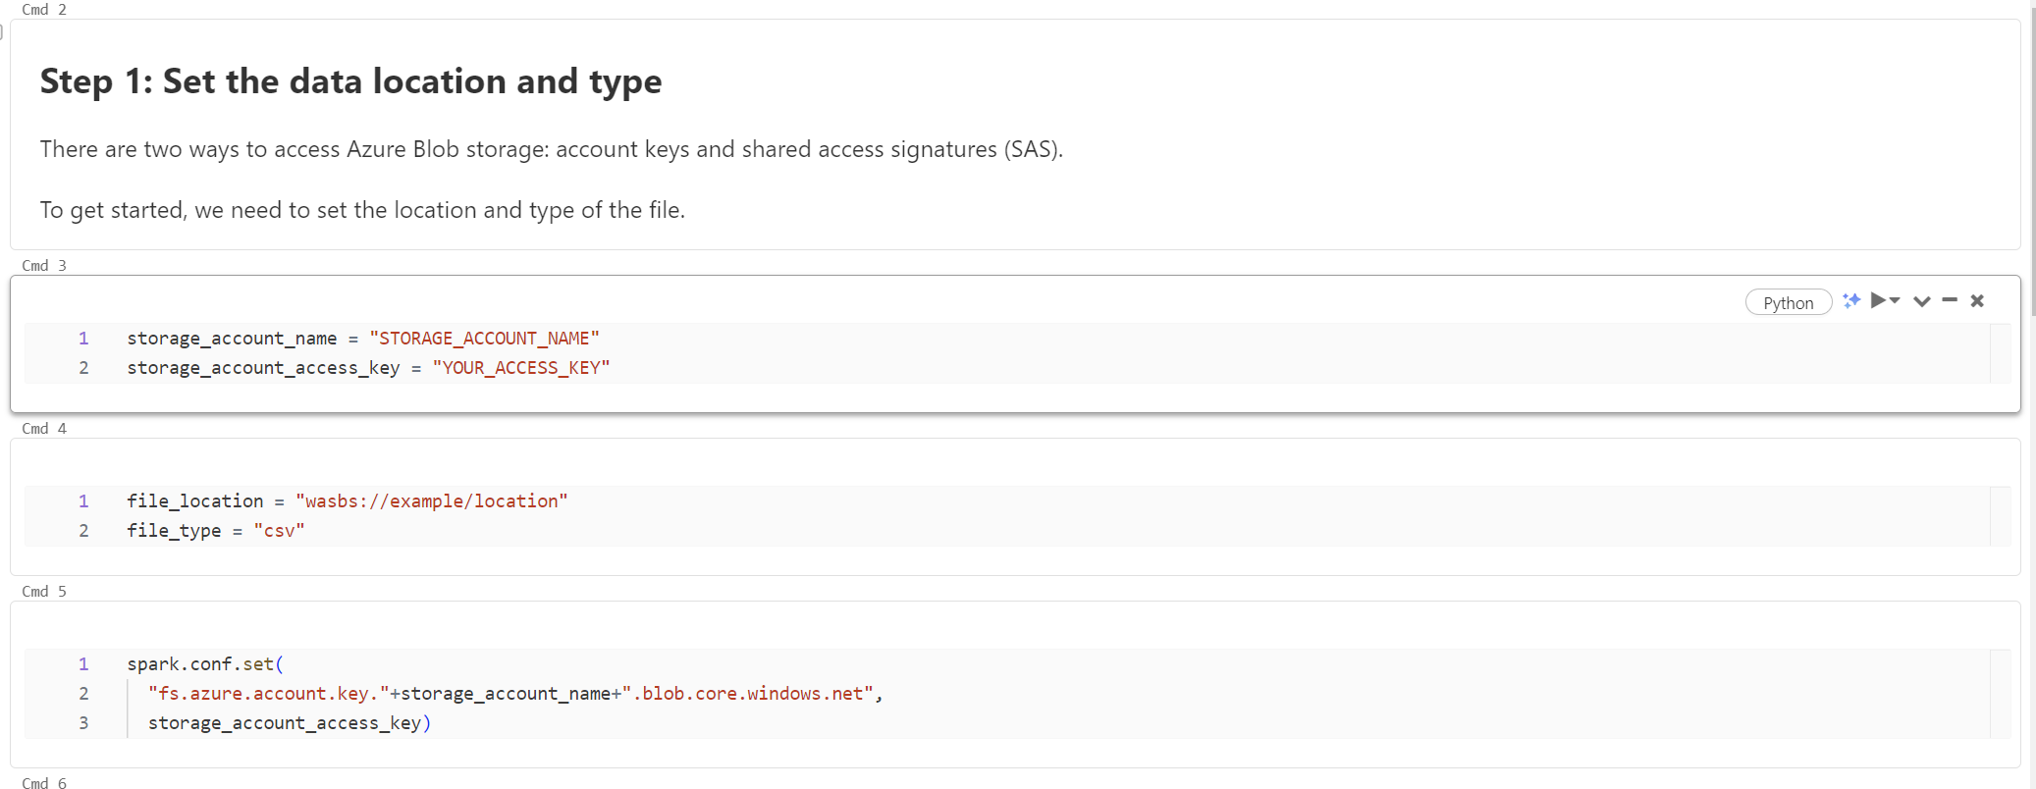

Reading the data

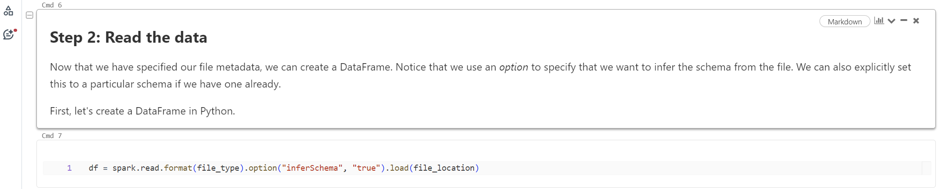

Querying using SQL

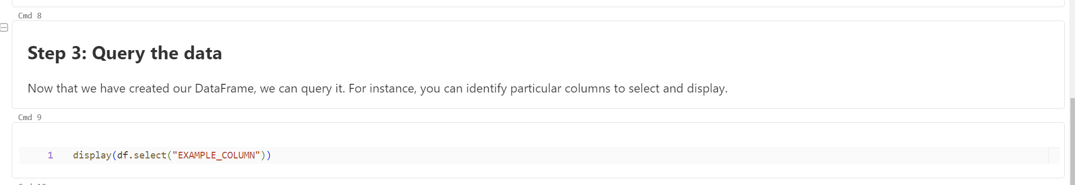

Creating view and table

